Cost-Savings Benefits Available to Solon Chamber Members

Health Insurance  Now you can get cost savings on your health insurance benefits usually reserved for larger companies. How? You get the purchasing power of the group insurance market through your chamber of commerce membership. PLUS, you also get access to the comprehensive care and quality providers you’ve come to expect.  There are two Anthem discount programs available to you through your local chamber of commerce.  1. ChamberSaver – traditional ACA plan. CLICK HERE to view informational flyer.  2. SOCA Benefit Plan MEWA – self-funded group plan for employee sizes 2-50. CLICK HERE to view informational flyer.  How do I enroll my company? Ask your current Anthem licensed agent for a quote with your NOACC chamber membership discount. If you are not currently working with a broker, let us help you find one in your area. Email libby@solonchamber.com to request a broker. | 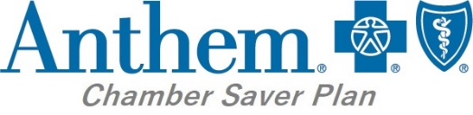  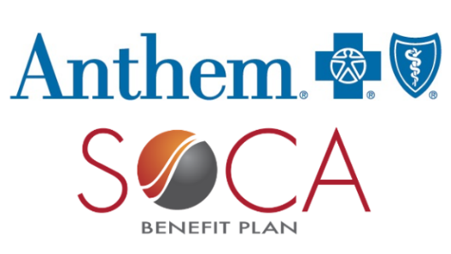
Chamber Merchant Services Solutions
We invite you to take advantage our BancCard Merchant Services offering which provides your business white glove service, REDUCED pricing, wholesale equipment, local and back up 24/7 service, and NO CONTRACT, all with a trusted twenty-five-year U.S. partner. Our payment processing solutions can be customized for you and used for ANY TYPE OF PAYMENT solution needed for your business or organization. This exciting offer is available to you just by being a chamber member.

Get Started
Reach out to Lisa Heller, 216-215-7547, lheller@banccard.com.
CLICK HERE for an informational flyer
Chamber Energy Solutions
The Chamber Energy Program and Chamber Sustainability Program strive to provide education and protection in everything we do. We help businesses lower their supply rates and maximize their efficiency project return on investment using a wide array of available federal, state, and local rebates, grants, incentives, and other funding options. With current funding available, your projects could be immediately cash-positive.

Get started with a free utility bill review by filling out and returning the back of this flyer to billreview@ceateam.com!

CLICK HERE to request a quote online.
Sedgwick Managed Care Ohio  How it works  The Solon Chamber of Commerce partners with Sedgwick because they help employers maximize their premium savings. Sedgwick analyzes each employer’s unique claim and premium history to find the highest level of savings in all available workers’ compensation programs.  How do I enroll my company? To allow Sedgwick Temporary Authorization to review your Workers Comp', please fill out this form and submit it via email to ohio.group@sedgwick.com. | 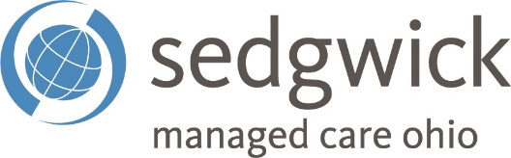
FedEx Discounts
NOACC members can get exceptional FedEx discounts. Start saving.
- 45% off on FedEx Express® shipping
- 45% off on FedEx Express international shipping
- 25% off on FedEx Ground® shipping
- 25% off on FedEx Home Delivery®

How it works
If you currently ship with FedEx, you’ll be able to continue using it the same way you do today. After you enroll, the discounts will be added to your account and then automatically applied to your shipments. Don’t have an account? No problem. You can open one when you enroll.

Get started
CLICK HERE to Enroll in the FedEx Advantage Program today to sign up for your FedEx discounts. You’ll receive confirmation once the discounts have been added to your account and you’re ready to start saving. If you have any questions, email fedex@PartnerShip.com or call 440-517-7275. CLICK HERE to view informational flyer.
Freight Savings  - As the endorsed shipping provider for NOACC, PartnerShip helps members reduce their LTL freight costs and ship smarter.  - Receive competitive pricing from TForce Freight, YRC, XPO, Saia, and others  - Benefit from personalized service from industry experts  - Gain access to tools to easily manage your shipments and save time  How it works  Put the PartnerShip team to work for you. They can provide you with quotes, schedule pickups, and handle any issues that come up with the carrier. Prefer to be more hands on? PartnerShip.com has everything you need to easily manage your account and set up your shipments.  Get started  CLICK HERE to get a quote on an upcoming shipment or create an account to start saving. If you have any questions, email sales@PartnerShip.com or call 800-599-2902. | 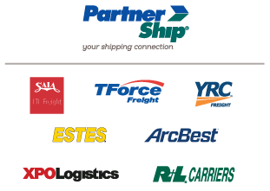
Prescription Savings Card  This program is being provided to you and your family to help lower your prescription drug costs.  Simply print your FREE Prescription Drug Coupon Card below and receive savings of up to 80% (discounts average roughly 30%) at more than 68,000 national and regional pharmacies. This coupon card can be used for potential savings on medications not covered by your insurance.  CLICK HERE to view/download card. | 